In Planning analytics some customers have been chosen manually.

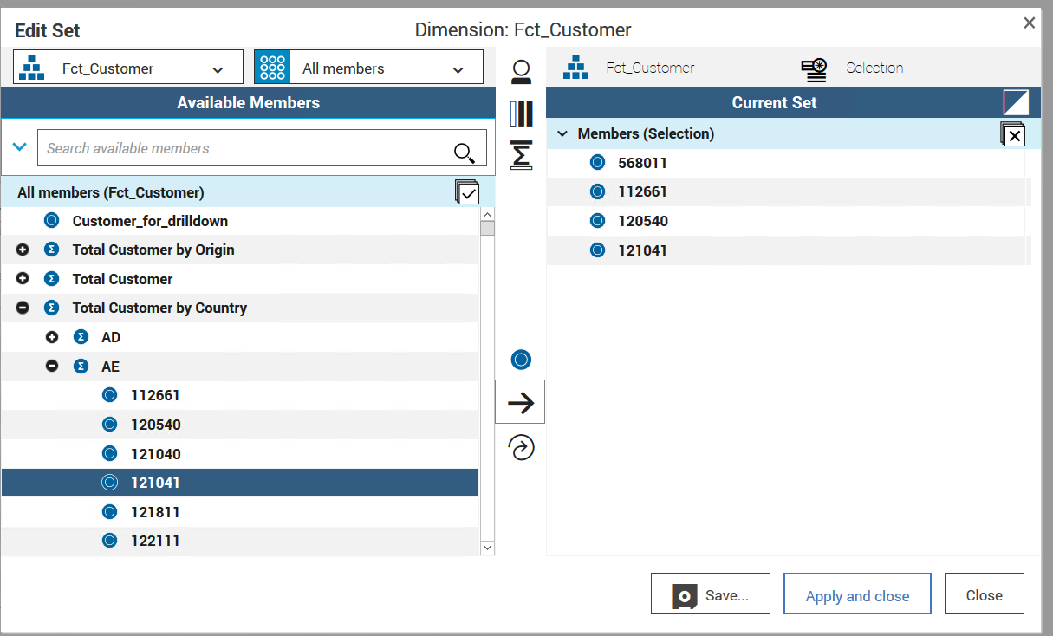

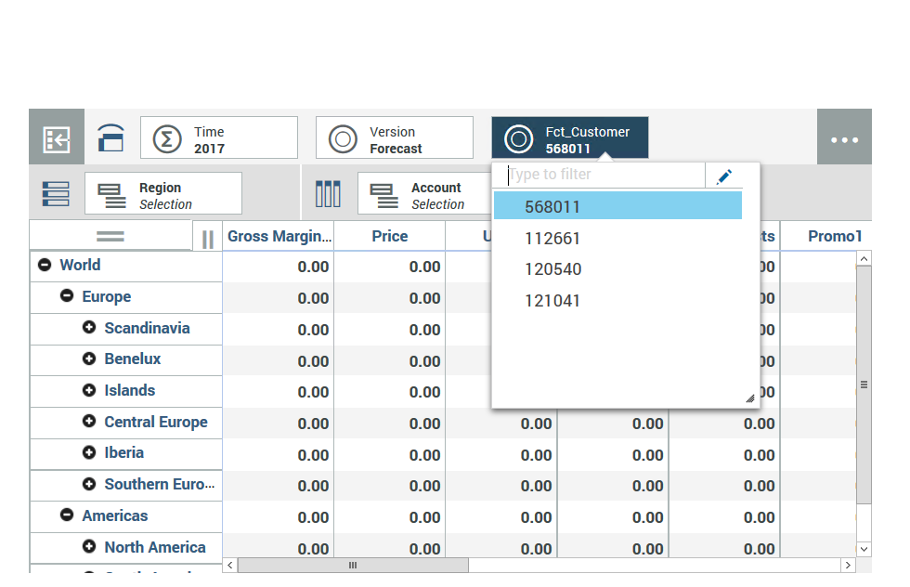

Customer 121041 was underneath AE

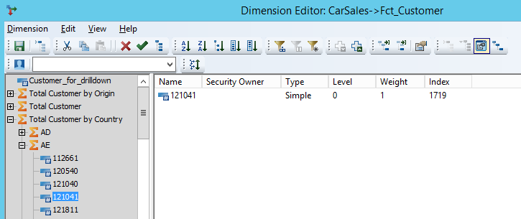

And is moved underneath AI

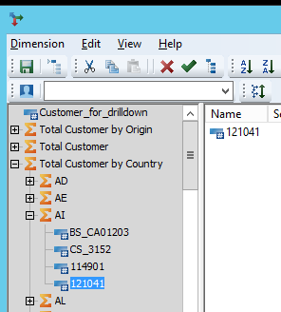

When reopening the PA workspace this error occurs :

